21ALL062 HTTP Request and Response:

Code:

Areacalc.html

<!DOCTYPE html>

<html lang="en">

<head>

    <meta charset="UTF-8">

    <meta http-equiv="X-UA-Compatible" content="IE=edge">

    <meta name="viewport" content="width=device-width, initial-scale=1.0">

    <title>Document</title>

</head>

<body>

    <form action="http://localhost:8080/caculatecirclearea" method="get">

        Enter Radius of circle : <input type="number" name="rad"> <br>

        Enter Length of Rectangle : <input type="number" name="len"> <br>

        Enter Breadth of Rectangle : <input type="number" name="brd"> <br>

        <button type="submit">CALCULATE</button>

    </form>

</body>

</html>

Calculatecirclearea.js

const http= require('http');

url= require('url');

http.createServer((req,res)=>

{

    console.log(req.url);

    var qs= url.parse(req.url,true).query;

    console.log(qs);

    console.log(qs.rad);

    var side=Number(qs.rad);

    var cirarea=(3.14)\*side\*side;

    var length=Number(qs.len);

    var breadth=Number(qs.brd);

    var recarea=length\*breadth;

    res.write("Area of the circle is "+cirarea);

    res.write("   Area of the rectangle is "+recarea);

    res.end();

}).listen(8080);

Running:

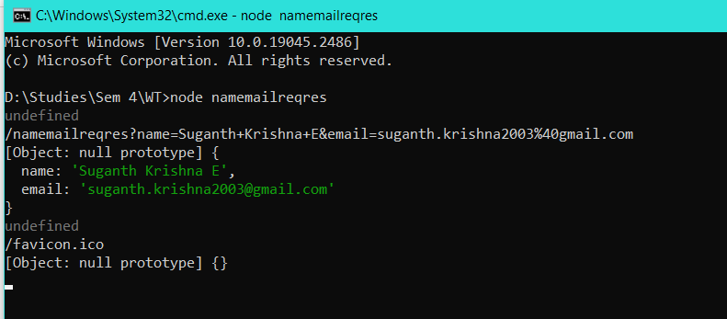

Output:

